An-Najah University Journal for Research – A  Natural Sciences | 

Effect of Bat Guano and Alpaca Manure on Germination, Growth, Flower Color Intensity, and Abiotic Stress Tolerance in Mirabilis jalapa L.
Domenico Prisa,* & Aftab Jamal²
(Type: Full Article). Received: 14th Nov. 2025, Accepted: 23rd Jan. 2026, Published: ××××, DOI: ××××
Received Accepted, In Press
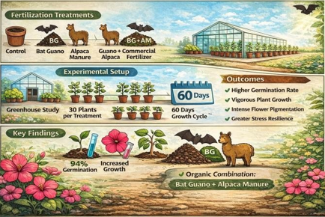
Abstract: This study investigated the impact of bat guano and alpaca manure, applied singularly or in combination, on the greenhouse production of Mirabilis jalapa L. The central question for this study was whether bat guano + alpaca manure would help plant propagation more than commercial fertilizer and other treatments. The five treatments included: no fertilizer (control), bat guano, alpaca manure, bat guano + alpaca manure, and a commercial fertilizer as a treatment. Among the treatments, bat guano + alpaca manure provided the best germination percentage (94%), plant height (32.1 cm), and fresh weight, and produced greater results than both the control and the commercial fertilizer. Flower colour was assessed by measuring the anthocyanin levels, which were highest with bat guano + alpaca manure, while commercial fertilizer provided some beneficial effects over the control. Plants that received organic treatments and the combination of bat guano + alpaca manure maintained more moisture and showed less decline in chlorophyll stability under adverse conditions, than those receiving either the control or commercial fertilizer. In general, bat guano + alpaca manure provided the best results in all assessments. While these results are unique for a single season in a greenhouse study and may not translate to other systems, bat guano and alpaca manure appear to be an effective combination for sustainable flower production.
Keywords: Anthocyanin Accumulation, Organic Nutrient, Greenhouse Ornamental Production, Drought Resilience, Sustainable Floriculture Inputs.

Introduction
The growing need for sustainable agriculture has increased the attention on the exploration of organic soil amendments to enhance plant growth and promote soil health while reducing environmental stress [1,2]. Animal manure is an important amendment because it provides key nutrients and organic matter associated with plant growth and physiological responses [3]. In this situation, the desirable model species, Mirabilis jalapa L. (four o'clock flowers), is an excellent candidate for pigment expression and stress physiology studies because of its high variability in flower colour and response to nutrient availability [4,5].
Bat guano and alpaca manure are gaining attention as organic functional fertilizers that contain both macro- and micronutrients. Bat guano is rich in nitrogen and phosphorus and appears to support vigorous seedling and vegetative growth of plants. They also been shown to introduce beneficial microbial populations that promote microbial activity in the rhizosphere and stimulate root growth [6,7]. Likewise, alpaca manure is comparable to guano, providing a balanced nutrient profile, low odor, and slow-release nutrients with less nutrient loss during greenhouse production [8,9]. The use of combination of these amendments may further support nutrient availability while maintaining microbial communities, thereby enhancing the overall sustainability of floriculture production systems. Bat guano is recognized as a nutrient-dense organic fertilizer, particularly rich in nitrogen and phosphorus, along with potassium and micronutrients, although its composition varies according to bat feeding habits and guano age [10,11]. Similarly, alpaca manure, a camelid-derived organic amendment, contains moderate levels of nitrogen (≈0.5–0.6%), phosphorus, potassium, and organic matter, and is characterized by slow nutrient release and minimal odor, making it suitable for greenhouse and container production systems [12].
Earlier research in ornamental horticulture has demonstrated that organic manures can improve flower yield, stem strength, flower color, and plant tolerance to abiotic stresses, such as drought and salinity [13,14]. Organic amendments also contribute to soil water holding capacity and beneficial microbial populations and help improve plant stress relief, all of which are particularly compelling traits when considering controlled greenhouses and soilless systems [15,16]. In addition, using organic fertilizers, which can often be sourced locally, has lower input costs and lower carbon emissions due to the lower transport distance/amount [14]. For example, estimates suggest that using local resources such as bat guano and alpaca manure can provide more than 30% less transportation emissions than commercial fertilizers transported many miles [17].
Unfortunately, little is known about the independent or combined effects of bat guano and alpaca manure on ornamental plants. However, little is known about their effects on anthocyanin accumulation and color intensity of flowers, two characteristics associated with a plant's physiological response to environmental stimuli [18,19]. Anthocyanins are flavonoid- derived secondary plant metabolites that are responsible for the red, purple, and blue coloration of flowers and other plant tissues. In addition to their role in pigmentation, anthocyanins are involved in plant responses to environmental stimuli, including nutrient availability and abiotic stress [20,21]. Since M. jalapa has exhibited sensitivity to nutrients and changes in flower color, testing these organic fertilizers may elucidate our understanding of ornamental quality and stress physiology in plants.
The current study was conducted under controlled greenhouse conditions to examine the effects of bat guano, alpaca manure, and a combination of both, on M. jalapa growth, pigment indices, and stress tolerance when compared to a commercial organic fertilizer. It was hypothesized that bat guano, alpaca manure, and a combination of the two would have a greater positive effect on seed germination, vegetative growth, flower pigment indices, and stress tolerance than a commercial organic fertilizer. It was supposed that bat guano, alpaca manure, and a combination of both manures would promote plant growth and stress responses due to the availability of beneficial nutrients and that they would similarly increase soil microbial activity.

Materials and Methods

Experimental Site and Conditions
The experiment was carried out under semi-controlled conditions in greenhouses at CREA (Agricultural Research Council), located in Pescia, Italy (43°54′ N, 10°41′ E), in the spring and summer of 2025. The greenhouse was built from polyethylene and had side ventilation, a tethered irrigation system, and temperature telemetry. The average daily temperatures ranged from 24 to 30°C, whereas the average nightly temperatures ranged from 16 to 20°C. The relative humidity was maintained at approximately 55 - 70 %. In addition, when the natural light intensity was below 300 µmol·m⁻²·s⁻¹, supplemental LED lights were turned on.

Plant Material and Seed Preparation
Mirabilis jalapa L. seeds obtained from a vendor approved by the International Plant Protection Organization. The seeds were selected for uniform size, sterilized with 1 percent sodium hypochlorite solution for 2 min and then rinsed thoroughly. Seed viability was greater than 90 percent, based on germination testing.

Growing Media and Pot Culture
Five-liter plastic pots were used as containers for each experimental unit. The pots contained a consistent growing medium of loamy soil, composted pine bark, and perlite in a volume ratio of 2:1:1. The growing medium was sterilized at 70 °C for two hours to reduce the presence of pathogens to acceptable levels. The pots were placed on greenhouse benches at a spacing of 30 cm to ensure equal light and airflow. The growing medium was sterilized to reduce soil-borne pathogens, weed seeds, and background microbial variability. The experiment was conducted under greenhouse (in vivo) conditions rather than in vitro systems. Sterilization was applied to ensure uniform starting conditions across treatments, while allowing microbial communities to re-establish during cultivation, particularly in organically amended substrates.

Fertilizer Treatments
The five fertilization treatments were as follows:
T1 (Control): No fertilizer applied; T2 (Bat Guano): 10 g of commercial powdered bat guano, incorporated into the top 5 cm of soil prior to sowing (Bat guano was applied as a commercially available powdered product, Plagron Batmix, NPK 10–3–1), T3 (Alpaca Manure, Buddy’s Premium Alpaca):
200 g of air-dry (Alpaca manure consisted of air-dried, composted material obtained from a local certified alpaca farm. The manure was composted under aerobic conditions prior to application to ensure stabilization and suitability for greenhouse use); T4 (Combination): 5 g bat guano and 100 g alpaca manure; T5 (Commercial Fertilizer, Microlife Ultimate): 5 g of a commercially available organic NPK (8-4-6) fertilizer targeted for use on flowering plants.
All fertilizers were added as base dressing at the time of sowing, and no additional topdressing was performed to follow a one-off application protocol. The application rate for each treatment was based on previous studies and, where appropriate, manufacturer recommendations. This was done to ensure that an adequate nutrient supply was available. The nitrogen input across the treatments was standardized as closely as possible based on the fertilizer composition and published nutrient analyses. Bat guano (NPK 10–3–1) applied at 10 g pot⁻¹ supplied approximately 1.0 g N pot⁻¹. Alpaca manure, with an estimated total nitrogen content of 0.5–0.6% (dry weight), supplied approximately 1.0–1.2 g N pot⁻¹ when applied at 200 g pot⁻¹. The combined treatment (5 g bat guano + 100 g alpaca manure) delivered approximately 1.0–1.1 g N pot⁻¹. The commercial organic fertilizer (NPK 8–4–6) applied at 5 g pot⁻¹ supplied approximately 0.4 g N pot⁻¹, consistent with manufacturer recommendations for ornamental container crops. Plants in all treatments received the same irrigation regime through drip systems, and the soil moisture was maintained at or near field capacity. An automated sensor system with tensiometers monitored soil moisture to provide consistent water to all treatments, which supported the validity of the results.

Experimental Design and Replication
The experiment was arranged in a completely randomized design (CRD) with five fertilization treatments and 30 replicates per treatment, resulting in a total of 150 experimental units. Each pot contained one plant and was considered an independent replicate of the experiment.

Data Collection Parameters Germination Rate
Emergence was monitored daily for 14 days after sowing (DAS). Seeds were considered germinated when the radicles emerged. The germination percentage was calculated as the number of germinated seeds divided by the total number of seeds per pot. The results were expressed as percentages.

Vegetative Growth
At 45 days after sowing (DAS), the plant height and stem diameter were measured two centimeters above the soil. The leaf numbers and both shoot and root fresh weights were recorded. Roots were carefully washed to remove the growing media while preserving fine root structures.

Flower Color Intensity and Morphology
At first full bloom (about 65 DAS), three flowers per plant were randomly selected for analysis. Flower diameter was measured using a digital caliper. Anthocyanin content was determined spectrophotometrically and expressed as relative optical density (OD₅₃₀) per gram of fresh petal tissue. Anthocyanins were extracted in acidified methanol (1% HCl), and the absorbance was measured at 530 nm using a UV–Vis spectrophotometer. No external reference standard was used, as the analysis aimed to compare the relative anthocyanin accumulation among treatments under identical extraction and measurement conditions. The results were reported as optical density per gram of fresh petal tissue.

Abiotic Stress Tolerance
At 60 DAS (days after sowing), both abiotic stress simulations were applied sequentially. Drought and salinity stress were imposed sequentially to avoid confounding interactive effects and better isolate plant physiological responses to cumulative abiotic stress. Drought stress was first applied by withholding irrigation for 7 days, simulating a common water-deficit scenario in containerized greenhouse systems. Following rehydration, salinity stress was imposed by irrigating the plants with 150 mM NaCl solution for five consecutive days. This sequence reflects the practical production conditions in which salinity stress may occur after drought during re-irrigation. Physiological parameters were measured after the completion of both stress phases to evaluate overall stress tolerance and recovery capacity. Leaf relative water content (RWC), chlorophyll stability index (CSI), and survival rate were measured. RWC was calculated using the following formula [22]:
RWC (%)= ^{𝐹𝑊−𝐷𝑊} × 100
𝑇𝑊−𝐷𝑊
where FW = fresh weight, TW = turgid weight, DW = dry weight.

Statistical analysis
Data were analyzed using one-way analysis of variance (ANOVA) appropriate for a completely randomized design (CRD). Treatment means were compared using the least significant difference (LSD) test at P ≤ 0.05. Statistical analyses were performed using CoStat (version 6.451) and Microsoft Excel (Office 2010). Each measured parameter was analyzed independently using a one-way analysis of variance (ANOVA) to evaluate the effects of the fertilization treatments. The reported significance levels indicate significant (P ≤ 0.05), highly significant (P ≤ 0.01), and very highly significant (P ≤ 0.001) treatment effects for each parameter. When ANOVA results were significant (P ≤ 0.05), treatment means were separated using the Least Significant Difference (LSD) test at P = 0.05.

Results

Seed Germination Response
Different types of organic inputs led to differences in the seed germination of Mirabilis jalapa (Table 1). The highest germination percentage was observed in the combination (BG+AM) treatment (93 %), which was significantly higher than bat guano (85 %), alpaca manure (81%), and commercial fertilizer (78%). The control was the lowest (72%).
Table (1): Germination and Plant Height of Mirabilis jalapa.
Treatment | Germination (%) | Plant Height (cm)
Control | 72±2.1 ^{d} | 21.3±1.2 ^{d}
Bat Guano | 85±2.4 ^{b} | 26.7±1.3 ^{b}
Alpaca M. | 81±1.9 ^{c} | 25.4±1.1 ^{c}
Combo (Guano + Alpaca) | 93±1.6 ª | 30.8±1.5 ª
Commercial F. | 78±2.3 ^{c} | 24.1±1.4 ^{c}
ANOVA | *** | ***
Values represent mean ± standard deviation (SD). Treatment effects were evaluated by one-way ANOVA, and mean separation was performed using Fisher’s least significant difference (LSD) test at P ≤ 0.05.

Vegetative Growth Performance
Plant height varied significantly among the treatments (Table 1). BG + AM treatment resulted in the tallest plants, with a height of 30.8 cm measured from the soil surface. The heights measured for the other treatments were 26.7 cm for bat guano (BG), 25.4 cm for alpaca manure (AM), 24.1 cm for commercial fertilizer (CF), and 21.3 cm for the control group (C). In addition, plants exposed to organic treatments, especially BG + AM, formed higher mass and more fibrous roots than those in the control treatment group, indicating a more thorough uptake of nutrients (Figure 1).
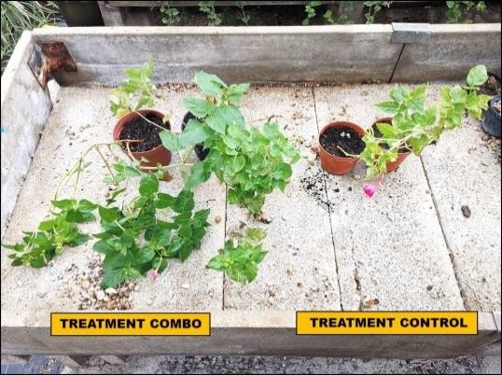
Figure (1): Effect of fertilization treatments on vegetative growth of Mirabilis jalapa. Representative plants from the control and bat guano + alpaca manure (BG+AM) treatments at 45 days after sowing (DAS). Significance levels refer to overall ANOVA treatment effects; mean separation was performed using LSD at P = 0.05.

Flower Color Intensity
Differences in anthocyanin content, as measured by optical density (OD530), between treatments were apparent (Fig. 2). The BG+AM flower had the highest pigment content (0.73 OD530), followed in descending order by bat guano (0.62), alpaca manure (0.57), and commercial fertilizer (0.51). The control was lowest (0.45).
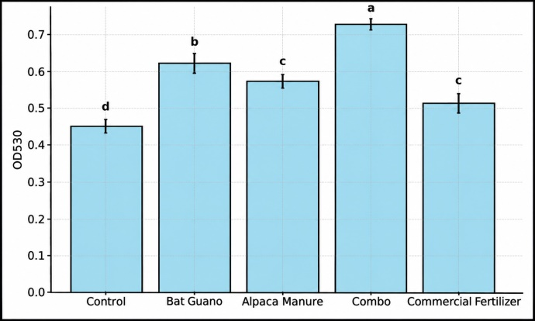
Figure 2: Effect of fertilization treatments on flower color intensity of Mirabilis jalapa. Anthocyanin content expressed as relative absorbance (OD₅₃₀) per gram of fresh petal tissue. Bars represent mean ± standard deviation (n = 30). Significance levels refer to overall ANOVA treatment effects; mean separation was performed using LSD at P = 0.05.

Flower Morphology
Organic treatments resulted in clear improvements in various flower-related characteristics, including flower quantity, size, petal thickness, and fresh weight (Table 2). On average, amending plants with bat guano and alpaca manure on average yielded the best results, with 16.4 flowers per plant, a flower diameter of 4.8 cm, a petal thickness of 0.65 mm, and a fresh flower weight of 3.9 grams. In contrast, the control group consistently had the lowest values for all traits.
Table (2): Flower Morphology Parameters in Mirabilis jalapa.
Treatment | Flowers /plant | Flower diameter (cm) | Petal thickness (mm) | Flower weight (g)
Control | 9.2 ± 1.1 ^{d} | 3.1 ± 0.2 ^{d} | 0.42 ± 0.03 ^{d} | 2.1 ± 0.2 ^{d}
Bat Guano | 13.8 ± 1.3 ^{b} | 4.2 ± 0.3 ^{b} | 0.58 ± 0.04 ^{b} | 3.4 ± 0.3 ^{b}
Alpaca Manure | 12.7 ± 1.2 ^{c} | 3.9 ± 0.2 ^{c} | 0.54 ± 0.03 ^{c} | 3.0 ± 0.3 ^{c}
Combo (BG+AM) | 16.4 ± 1.5 ª | 4.8 ± 0.3 ª | 0.65 ± 0.04 ª | 3.9 ± 0.4 ª
Commercial Fertilizer | 11.5 ± 1.1 ^{c} | 3.6 ± 0.2 ^{c} | 0.50 ± 0.03 ^{c} | 2.7 ± 0.2 ^{c}
ANOVA | *** | *** | *** | ***
Values represent mean ± standard deviation. Significance levels refer to overall ANOVA treatment effects; mean separation was performed using LSD at P = 0.05.

Abiotic Stress Tolerance
The group receiving bat guano + alpaca manure (BG + AM), measured the highest relative water content (RWC) of the evaluated treatments (84%), bat guano (76%), alpaca manure (74%), commercial fertilizer (69%), and control (62%) (Figure 3). These findings indicate that the plants treated with the organic treatments were able to hold more water, providing them with greater resilience in the face of stress. Chlorophyll stability index (CSI) did significantly depend on treatment (Figure 4). The CSI was highest in the BG + AM treatment (0.91), followed by bat guano (0.82), alpaca manure (0.79), commercial fertilizer (0.74), and control (0.68).
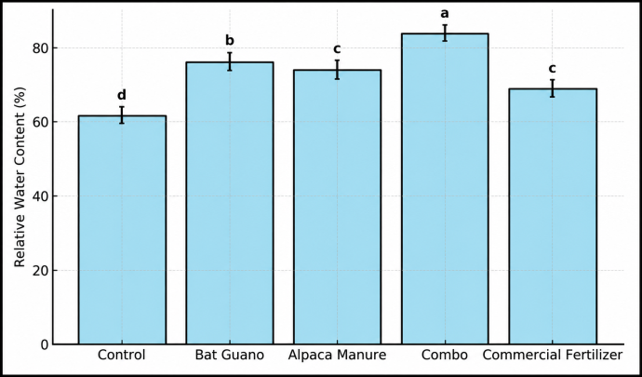
Figure 3: Relative water content (RWC) of Mirabilis jalapa Leaves under combined drought and salinity stress. Values represent mean ± standard deviation (n = 30). Significance levels refer to overall ANOVA treatment effects; mean separation was performed using LSD at P = 0.05.
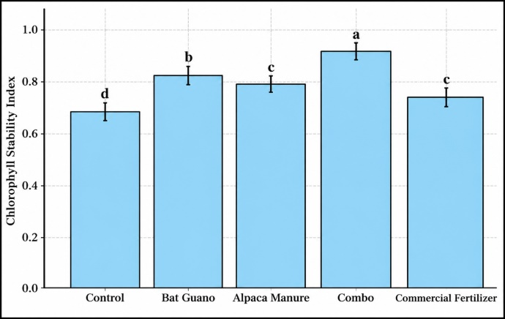
Figure 4: Chlorophyll stability index (CSI) of Mirabilis jalapa plants following abiotic stress treatments. Bars represent mean ± standard deviation (n = 30). Significance levels refer to overall ANOVA treatment effects; mean separation was performed using LSD at P = 0.05.
Plant survival after drought and salt stress varied by treatment (Figure 5). The BG+AM group had the highest survival rate at 94%, followed by bat guano (88%), alpaca manure (85%), commercial fertilizer (82%), and control (78%).
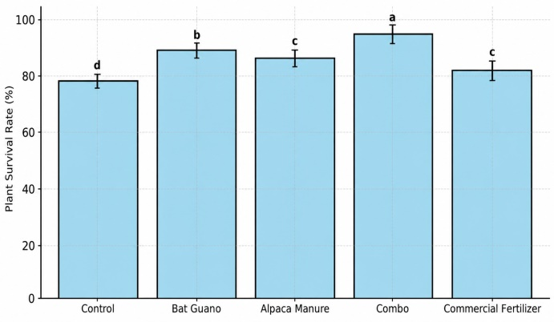
Figure 5: Survival rate of Mirabilis jalapa plants after sequential drought and salinity stress. Data represent mean survival percentage ± standard deviation (n = 30). Significance levels refer to overall ANOVA treatment effects; mean separation was performed using LSD at P = 0.05.

Discussion
The most prominent outcome of this study was the consistently superior performance of Mirabilis jalapa plants receiving the combined application of bat guano and alpaca manure across all evaluated parameters. Compared with individual organic amendments, commercial fertilizer, and the unfertilized control, the combined treatment significantly enhanced seed germination, vegetative growth, flower number and size, anthocyanin accumulation, and tolerance to drought and salinity stress. These results indicate a synergistic interaction between the two organic inputs, likely arising from complementary nutrient release patterns and improved substrate conditions.
Bat guano provides readily available nitrogen and phosphorus that support early seedling establishment and rapid vegetative growth, while alpaca manure contributes a slower, sustained nutrient supply and organic matter that enhances microbial activity and water-holding capacity. The integration of these two amendments appears to optimize nutrient availability throughout the plant growth cycle, thereby improving both ornamental quality and physiological resilience.

Seed Germination and Early Growth
The improved germination rate and seedling vigor seen in treatments using bat guano and BG + AM were likely due to greater levels of P and N found in guano, which improves both enzymatic action and the emergence of roots [18,19]. Alpaca manure supported slower but more stable releases of nutrients, improving conditions in the substrate and balance with microbes, which reflects earlier findings on organic inputs as improvements to germination [23-25].

Vegetative Development
The enhanced growth of vegetative phase growth under the combined treatment indicates a complementary nutrient release profile: bat guano provides a boost of immediately available nutrients, while alpaca manure provides sustained release of minerals. The two phases of nutrient release would have had an additive effect, likely maintaining vegetative growth throughout the vegetative phase [26,27]. The improvement of root structure noticed in the organic amendments is consistent. with other studies, which had findings of improved rhizosphere health, nutrient uptake in organically-manage systems [28].

Flower Pigmentation and Morphology
The maximum increase of anthocyanins was noted at BG+AM, suggesting that organic inputs have activated the phenylpropanoid pathway related to pigment accumulation. The nutrient substrates, such as nitrogen and micronutrients like Mg, Fe, and the humic substances in the AM treatment may have contributed to sustained expression of flower pigments by promoting flavonoid biosynthetic pathways [29-31]. Similar increases in flower size and colors have been demonstrated regarding marigold and zinnia grown in organic nutrient systems [32]. The benefits related to flower morphology associated with organic regimes indicated better allocation of resources to vegetative and reproductive growth for ornamental plants. The greater number and fresh mass of flowers implies greater nutrient allocation efficiency towards reproductive tissues [33].

Abiotic Stress Resilience
The improved osmotic regulation, membrane integrity, and stability of chlorophyll associated with elevated RWC and CSI in organically treated plants may be due to a higher availability of potassium and organic acids within manure and guano [34- 37]. The superior stress resilience of BG+AM= treated plants provide support for hypotheses that, by including soil amendments with organic matter and microbial activity, we can develop plants, and plant-soil systems more resilient to drought stress, [38-41].

Comparison with Commercial Fertilizer
While the commercial organic fertilizer enhanced plant performance relative to the unfertilized control, it consistently underperformed relative to the organic amendments [42]. The limitations of microbial diversity and insufficient complex organic compounds in processed fertilizers may have contributed to the greater effectiveness of the natural inputs [43,44]. In addition to nutrients, natural inputs supplied relevant biostimulants that stimulated pigment synthesis, flower initiation, and abiotic stress [45].

Agronomic Implications
The synergistic effects associated with bat guano and alpaca manure demonstrate viable sources for sustainable, local production inputs in ornamental crops [46,47]. Mixed use promoted growth, color intensity and stress tolerance while also reducing the need for chemical fertilizers [48]. These practices align with sustainability goals in floriculture while also serving a purpose in protected cultivation systems [49-53].
The enhanced vegetative growth and biomass accumulation observed under the combined bat guano and alpaca manure treatment may also be partially associated with indirect stimulation of cell division and expansion processes. Organic manures are known to contain or promote the production of enzyme cofactors, humic substances, and phytohormone-like compounds, such as auxins, cytokinins, and gibberellins, either inherently or through enhanced microbial activity in the rhizosphere [54]. These bioactive compounds can stimulate meristematic activity, cell division, and tissue differentiation, thereby contributing to improved plant growth and development. Although phytohormones and enzyme activities were not directly measured in this study, the superior growth performance and root development observed in organically amended treatments are consistent with previous reports attributing similar responses to hormone-mediated and enzyme-regulated physiological processes in plants grown with organic fertilizers.

Conclusion
This study demonstrates that bat guano and alpaca manure, particularly when applied in combination, can significantly enhance the germination, vegetative growth, flower pigmentation, and abiotic stress tolerance of Mirabilis jalapa under controlled greenhouse conditions. However, as the experiment was conducted during a single growing season in a greenhouse environment, these results should be considered preliminary and may not be directly extrapolated to other climatic conditions, cultivation systems, or crop species.
Rather than advocating the complete substitution of commercial fertilizers, the present findings highlight the potential of bat guano and alpaca manure as promising organic inputs or complementary fertilization strategies for sustainable ornamental production. Further long-term, multi-season, and field-based studies are required to confirm their agronomic consistency, economic feasibility, and broader applicability before definitive recommendations can be made for their use.
The enhanced germination and plant growth in the combined treatment points toward a complementary pattern of nutrient release from bat guano, which possesses rapidly available nutrients mainly phosphorus and nitrogen, and alpaca manure serves as an additive to maintain soil value through its action in supporting microbial activity and building up the soil profile. Flower pigmentation is generally elevated in plants grown in organically amended soils, and organically treated plants had greater pigment development which correlated strongly with nutrient availability and secondary metabolism. In addition to pigment concentration and quality, the physiological performance for abiotic stress further indicates an improvement in the plant's physiology, with more visible recovery and relative water content does proving that organic amendments can increase resilience to environmental force factors, which is valuable for sustainable horticultural production systems that require resilience with efficient input use. Future studies should consider evaluations at a field scale and the addition of economic viability and potential effects on soil microbiota and soil fertility in the long term to provide more support for the use of organic amendments in environmentally responsible production systems.
In addition to improved nutrient availability, the positive effects of bat guano and alpaca manure particularly when applied in combination may be partly attributed to the indirect stimulation of physiological processes related to cell division and growth. The presence of organic matter and microbially mediated bioactive compounds in these animal-derived fertilizers may enhance enzyme activity and phytohormone-like signaling, thereby supporting sustained plant growth. However, further studies incorporating direct measurements of hormonal profiles and enzymatic activity are required to confirm these mechanisms of action.

Disclosure Statement
- Ethics approval and consent to participate: Not applicable
- Consent for publication: Not applicable
- Availability of data and materials: The raw data required to reproduce these findings are available in the body and illustrations of this manuscript.
- Author's contribution: The authors confirm their contribution to the paper as follows: study conception and design: D.P.; data analysis and validation: D.P & A.J.; draft manuscript preparation: D.P. Editing and writing: A.J. All authors reviewed the results and approved the final version of the manuscript.
- Funding: This research received no external funding.
- Conflicts of interest: The authors declare that there is no conflict of interest regarding the publication of this article
- Acknowledgments: The authors would like to express his heartfelt gratitude to colleagues and providers of plants and to all other sources for their cooperation and guidance in writing this article. We thank the anonymous reviewers for critical consideration of the manuscript.

Open Access
This article is licensed under a Creative Commons Attribution 4.0 International License, which permits use, sharing, adaptation, distribution and reproduction in any medium or format, as long as you give appropriate credit to the original author(s) and the source, provide a link to the Creative Commons licence, and indicate if changes were made. The images or other third party material in this article are included in the article's Creative Commons licence, unless indicated otherwise in a credit line to the material. If material is not included in the article's Creative Commons licence and your intended use is not permitted by statutory regulation or exceeds the permitted use, you will need to obtain permission directly from the copyright holder. To view a copy of this license, visit https://creativecommons.org/licenses/by-nc/4.0/

References
- Ghadirnezhad Shiade S.R., Fathi A., Minkina T., Wong M.H., Rajput V.D. Biochar application in agroecosystems: a review of potential benefits and limitations. Environment, Development and Sustainability. 2024; 26(8):19231–19255. DOI: https://doi.org/10.1007/s10668-023-03470-z
- Kiani H., Khalesro S., Mokhatssi-Bidgoli A., Sharifi Z., Biochar and conservation tillage affect the agronomic performance and fatty acid composition of Nigella sativa L. under both irrigated and dryland conditions. Scientific Reports. 2024;14(1):2648. DOI: https://doi.org/10.1038/s41598-024-52425-5
- Bolan N.S., Saggar S., Luo J., Bhandral R., Singh J. Gaseous emissions of nitrogen from grazed pastures: processes, measurements and modelling, environmental implications, and mitigation. Advances in Agronomy. 2004; 84:37–120. DOI: https://doi.org/10.1016/S0065-2113(04)84002-1
- Md. Harun-Or-Rashid. Antioxidant, antibacterial, cytotoxic and thrombolytic activities of flowers of Mirabilis jalapa L: Possible role of phenolics and flavonoids. Journal of Agriculture and Food Research. 2023; 14: 100893 DOI: https://doi.org/10.1016/j.jafr.2023.100893
- Liu H., Liu Z., Wu Y., Zheng L., Zhang G. Regulatory mechanisms of anthocyanin biosynthesis in apple and pear. International Journal of Molecular Sciences. 2021; 22(16):8441. DOI: https://doi.org/10.3390/ijms22168441
- Abd Rahman S.-S.N., Tawie Tingga R.C., Mohamad Bukhori M.F., Abd Aziz Abdullah S.M.A.M. A brief review of the nutritive value and chemical components of bat guano and its potential use as a natural fertiliser in agriculture. Borneo Journal of Resource Science and Technology. 2023; 13(1):22–31. DOI: https://doi.org/10.33736/bjrst.5100.2023
- Enríquez-Acevedo T., Pérez-Torres J., Ruiz-Agudelo C. Seed dispersal by fruit bats in Colombia generates ecosystem services. Agronomy for Sustainable Development. 2020; 40:45. DOI: https://doi.org/10.1007/s13593-020-00645-0
- Ewulo B.S., Ojeniyi S.O., Akanni D.A. Effect of poultry manure on selected soil physical and chemical properties, growth, yield and nutrient status of tomato. African Journal of Agricultural Research. 2008; 3:612–616.
- McGregor B.A., Brown A.J. Soil nutrient accumulation in alpaca latrine sites. Small Ruminant Research. 2010; 94(1–3):17–24. DOI: https://doi.org/10.1016/j.smallrumres.2010.06.004
- Dimande P., Arrobas M., Rodrigues M.Â. Under a tropical climate and in sandy soils, bat guano mineralises very quickly, behaving more like a mineral fertiliser than a conventional farmyard manure. Agronomy. 2023; 13:1367. DOI: https://doi.org/10.3390/agronomy13051367
- Misra P.K., Gautam N.K., Elangovan V. Bat guano: a rich source of macro and microelements essential for plant growth. Annals of Plant and Soil Research. 2019;21(1):82–86.
- Montemurro F., Maiorana M., Convertini G., Ferri D. Compost organic amendments in fodder crops: effects on yield, nitrogen utilization and soil characteristics. Compost Science & Utilization. 2006;14(2):114–123.
- Lambers H., Oliveira R.S. Mineral Nutrition. In: Plant Physiological Ecology. Springer, Cham. 2019. DOI: https://doi.org/10.1007/978- 3-030-29639-1_9
- Islam M.A.; Islam S.; Akter A.; Rahman M.H.; Nandwani D. Effect of Organic and Inorganic Fertilizers on Soil Properties and t he Growth, Yield and Quality of Tomato in Mymensingh, Banglade sh. Agriculture. 2017; 7: 18. DOI: https://doi.org/10.3390/agriculture7030018
- Guignard MS, Leitch AR, Acquisti C, Eizaguirre C, Elser JJ, Hessen DO, Jeyasingh PD, Neiman M, Richardson AE, Soltis PS, Soltis DE, Stevens CJ, Trimmer M, Weider LJ, Woodward G and Leitch IJ. Impacts of Nitrogen and Phosphorus: From Genomes to Natural Ecosystems and Agriculture. Front. Ecol. Evol. 2017; 5:70. DOI: https://doi.org/10.3389/fevo.2017.00070
- Cao Z., Deng F., Wang R., Li J., Liu X., Li D. Bioaugmentation on humification during co-composting of corn straw and biogas slurry. Bioresource Technology. 2023;374:128756.DOI: https://doi.org/10.1016/j.biortech.2023.128756
- Emerson J.K., Alison M. Composition of guano produced by frugivorous, sanguivorous, and insectivorous bats. Acta Chiropterologica. 2007;9(1):261–267.DOI: https://doi.org/10.3161/150811007781694525
- Jarosz R., Mierzwa-Hersztek M., Gondek K., Kopeć M., Lošák T., Marcińska-Mazur L. Changes in quantity and quality of organic matter in soil after application of poultry litter and poultry litter biochar—5-year field experiment. Biomass Conversion and Biorefinery. 2022;12(7):2925–2934. https://doi.org/10.1007/s13399-020-01005-4
- Chalker-Scott L. Environmental significance of anthocyanins in plant stress responses. HortTechnology. 1999;9(1):1–5.DOI: https://doi.org/10.1111/j.1751-1097.1999.tb01944.x
- Liu Y., Tikunov Y., Schouten R.E., Marcelis L.F.M., Visser R.G.F., Bovy A. Anthocyanin biosynthesis and degradation mechanisms in solanaceous vegetables: a review. Frontiers in Chemistry. 2018;6:52.DOI: https://doi.org/10.3389/fchem.2018.00052
- Câmara J.S., Locatelli M., Pereira J.A.M., Oliveira H., Arlorio M., Fernandes I., Perestrelo R., Freitas V., Bordiga M. Behind the scenes of anthocyanins—from the health benefits to potential applications in food, pharmaceutical and cosmetic fields. Nutrients. 2022;14:5133. DOI: https://doi.org/10.3390/nu14235133
- Jain S., Lamo K., Walling S., Imchen A., Tirkey J.F., Pratyush, Singh A., Singh A. Climate-resilient horticulture: adapting to climate change through innovative practices and technologies. International Journal of Environment and Climate Change. 2024;14(11):219–233. DOI: https://doi.org/10.9734/ijecc/2024/v14i114541
- Chandel A., Thakur M., Singh G. Flower regulation in floriculture: an agronomic concept and commercial use. Journal of Plant Growth Regulation. 2023;42(6):2136–2161. DOI: https://doi.org/10.1007/s00344-022-10688-0
- Hasan M.M., Hasan M.M., Teixeira da Silva J.A., Li X. Regulation of phosphorus uptake and utilization: transitioning from current knowledge to practical strategies. Cellular and Molecular Biology Letters. 2016;21:7. DOI: https://doi.org/10.1186/s11658-016-0008- y
- Kostin JE, Cesarz S, Lochner A, Schädler M, Macdonald CA, Eisenhauer N. Land‐use drives the temporal stability and magnitude of soil microbial functions and modulates climate effects. Ecological Applications. 2021;31(5):e02325. DOI: https://doi.org/10.1002/eap.2325
- Rayne N., Aula L. Livestock manure and the impacts on soil health: a review. Soil Systems. 2020;4:64. DOI: https://doi.org/10.3390/soilsystems4040064
- Butler T.J., Han K.J., Muir J.P., Weindorf D.C., Lastly L. Dairy manure compost effects on corn silage production and soil properties. Agronomy Journal. 2008;100:1541–1545. DOI: https://doi.org/10.2134/agronj2008.0033
- Agbede T.M., Ojeniyi S.O., Adeyemo A.J. Effect of poultry manure on soil physical and chemical properties, growth and grain yield of sorghum in Southwest Nigeria. American-Eurasian Journal of Sustainable Agriculture. 2008;2:72–77.
- Busari M.A., Salako F.K., Adetunji M.T. Soil chemical properties and maize yield after application of organic and inorganic amendments to an acidic soil in Southwestern Nigeria. Spanish Journal of Agricultural Research. 2008;6:691–699. DOI: https://doi.org/10.5424/sjar/2008064-362
- Assefa S., Tadeses S. The principal role of organic fertiliser on soil properties and agricultural productivity: a review. Agricultural Research and Technology: Open Access Journal. 2019;22(2):46–50. DOI: https://doi.org/10.19080/ARTOAJ.2019.22.556192
- Mukamparirwa V., Maliondo S.M.S., Mugunga C.P. Synergistic and antagonistic effects of mixed-leaf litter decomposition on nutrient cycling. Plants. 2024;13:3204. https://doi.org/10.3390/plants13223204
- Szpak E., Millaire P., White J.-F., Christine D., Longstaffe F.J. Influence of seabird guano and camelid dung fertilization on the nitrogen isotopic composition of field-grown maize (Zea mays). Journal of Archaeological Science. 2012;39(12):3721–3740. DOI: https://doi.org/10.1016/j.jas.2012.06.035
- Al-Salhi A, Al-Shatty S, Al-Imara E, Al-Rikabi A. Manufacturing a bacterial starter and a digital bio fermenter to treat poultry manure and produce methane gas, CH₄. AnNajah Univ J Res A (Nat Sci). 2025;39(3). DOI: https://doi.org/10.35552/anujr.a.39.3.2696
- Ding Y., Gao X., Shu D., Siddique K.H.M., Song X., Wu P., Li C., Zhao X. Enhancing soil health and nutrient cycling through soil amendments: improving the synergy of bacteria and fungi. Science of the Total Environment. 2024;923:171332. DOI: https://doi.org/10.1016/j.scitotenv.2024.171332
- Hughes N. M., Neufeld H. S., Burkey K. O. Functional role of anthocyanins in high‐light winter leaves of the evergreen herb Galax urceolata. New Phytologist. 2005; 168(3): 575-587.
- Hasanuzzaman M., Nowroz F., Raihan M.R.H., Siddika A., Alam M.M., Prasad P.V.V. Application of biochar and humic acid improves the physiological and biochemical processes of rice (Oryza sativa L.) in conferring plant tolerance to arsenic-induced oxidative stress. Environmental Science and Pollution Research. 2024;31(1):1562–1575. DOI: https://doi.org/10.1007/s11356-023-31119-x
- Faňanás-Pueyo I., Carrera-Castaño G., Pernas M., Oñate- Sánchez L. Signalling and regulation of plant development by carbon/nitrogen balance. Physiologia Plantarum. 2025;177(2):e70228. DOI: https://doi.org/10.1111/ppl.70228
- Munns R. Tester M. Mechanisms of salinity tolerance. Annual Review of Plant Biology. 2008;59:651–681. DOI: https://doi.org/10.1146/annurev.arplant.59.032607.092911
- Rajasekaran L.R., Blake T.J. New plant growth regulators protect photosynthesis and enhance growth under drought of jack pine seedlings. Journal of Plant Growth Regulation. 1999;18(4):175– 181. DOI: https://doi.org/10.1007/PL00007067
- Cucu M.A., Choudhary R., Trkulja V., Garg S., Matić S. Utilizing environmentally friendly techniques for the sustainable control of plant pathogens: a review. Agronomy. 2025;15:1551. DOI: https://doi.org/10.3390/agronomy15071551
- Holatko J., Hammerschmiedt T., Latal O., Kintl A., Mustafa A., Baltazar T., Malicek O., Brtnicky M. Deciphering the effectiveness of humic substances and biochar-modified digestates on soil quality and plant biomass accumulation. Agronomy. 2022;12(7):1587. DOI: https://doi.org/10.3390/agronomy12071587
- He D., Luo Y., Zhu B. Feedstock and pyrolysis temperature influence biochar properties and its interactions with soil substances: insights from a DFT calculation. Science of the Total Environment. 2024;922:171259. DOI: https://doi.org/10.1016/j.scitotenv.2024.171259
- Hossain M.Z., Bahar M.M., Sarkar B., Donne S.W., Ok Y.S., Palansooriya K.N., Kirkham M.B., Chowdhury S., Bolan N. Biochar and its importance on nutrient dynamics in soil and plant. Biochar. 2020;2(4):379–420. DOI: https://doi.org/10.1007/s42773-020-00065-z
- Hu H., Xi B., Tan W. Effects of sulfur-rich biochar amendment on microbial methylation of mercury in rhizosphere paddy soil and methylmercury accumulation in rice. Environmental Pollution. 2021;286:117290. DOI: https://doi.org/10.1016/j.envpol.2021.117290
- Tittarelli F., Ceglie F.G., Ciaccia C., Mimiola G., Amodio M.L., Colelli G. Organic strawberry in Mediterranean greenhouse: effect of different production systems on soil fertility and fruit quality. Renewable Agriculture and Food Systems. 2017;32(6):485–497. DOI: https://doi.org/10.1017/S1742170516000417
- Hung C.-Y., Hussain N., Husk B.R., Whalen J.K. Ammonia volatilization from manure mixed with biochar. Canadian Journal of Soil Science. 2021;102(1):177–186. DOI: https://doi.org/10.1139/cjss-2021-0029
- Janu R., Mrlik V., Ribitsch D., Hofman J., Sedláček P., Bielská L., Soja G. Biochar surface functional groups as affected by biomass feedstock, biochar composition and pyrolysis temperature. Carbon Resources Conversion. 2021;4:36–46. DOI: https://doi.org/10.1016/j.crcon.2021.01.003
- Guest G., Smith W., Grant B., VanderZaag A., Desjardins R., McConkey B. A comparative life cycle assessment highlighting the trade-offs of a liquid manure separator-composter in a Canadian dairy farm system. Journal of Cleaner Production. 2017;142:824– 835. DOI: https://doi.org/10.1016/j.jclepro.2016.12.041
- Palita S.K., Panigrahi R. & Panda D. Potentiality of Bat Guano as Organic Manure for Improvement of Growth and Photosynthetic Response in Crop Plants. Proc. Natl. Acad. Sci. India, Sect. B Biol. Sci. 2021; 91: 185–193. DOI: https://doi.org/10.1007/s40011- 020-01205-y
- Win P.P., Park H.-H., Kuk Y.-I. Integrated approach of using biostimulants for improving growth, physiological traits, and tolerance to abiotic stressors in rice and soybean. Agronomy. 2025;15:2265. DOI: https://doi.org/10.3390/agronomy15102265
- Hernández T., Chocano C., Moreno J.-L., García C. Towards a more sustainable fertilization: combined use of compost and inorganic fertilization for tomato cultivation. Agriculture, Ecosystems and Environment. 2014;196:178–184. DOI: https://doi.org/10.1016/j.agee.2014.07.006
- Ebert A.W. The Role of Vegetable Genetic Resources in Nutrition Security and Vegetable Breeding. Plants. 2020; 9: 736. DOI: https://doi.org/10.3390/plants9060736
- Jin X., Zhang T., Hou Y., Bol R., Zhang X., Zhang M., Yu N., Meng J., Zou H., Wang J. Review on the effects of biochar amendment on soil microorganisms and enzyme activity. Journal of Soils and Sediments. 2024;24(7):2599–2612. DOI: https://doi.org/10.1007/s11368-024-03841-7
- Guan L., Ji X., Sun T., Mu Y., Wang Y., Han Y., Sun Y., Li X., Xie K., Zhang S. Differential metabolite analysis of anthocyanins in variously colored petal types during different developmental stages of Sophora japonica L. Horticulturae. 2025;11:143. DOI: https://doi.org/10.3390/horticulturae11020143

CREA, Research Centre for Vegetable and Ornamental Crops, Via Dei Fiori 8, 51012 Pescia, Italy. * Corresponding author email: domenico.prisa@crea.gov.it 2 Department of Soil and Environmental Sciences, Faculty of Crop Production Sciences, The University of Agriculture, Peshawar 25130, Pakistan. aftabses98@gmail.com

